**IOT BASED NOISE POLLUTION MONITORING**

A project report submitted in partial fulfillment of therequirements for the degree of B.TECH information technology

By

RAMYA.G-513221205013

Under the supervision of professor and HOD department B.TECH Information Technology

**NOISE POLLUTION MONITORING**

**PHASE 4: DEVELOPMENT (PART-2)**

## [***Environmental Noise and Technology***](https://www.sciencedirect.com/science/article/pii/B9780128201008000063)

SONYC is a project based at New York University that has developed a smart cities sensor network with machine-listening capabilities to identify and mitigate the sources of noise pollution. The project's noise-monitoring system includes a hybrid, distributed network of sensors for large-scale noise reporting.

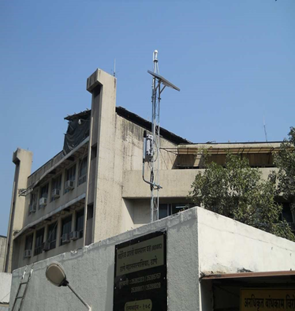

**Development of Ambient Noise Monitoring Network in India**

With increasing urbanization and industrialization, noise pollution particularly in ambient is also increasing. Government of India have taken number of steps to control noise pollution such as notifying noise rules-2009 and prescribing noise standards for vehicles, generators sets, fire crackers etc.

Till now Maharashtra Pollution Control Board is carrying out noise monitoring in urban area during festival periods (Diwali and Ganapati) and ambient noise monitoring in 6 major cities of Maharashtra is being carried out once in a year at fixed locations and the reports of these monitoring are being displayed in the public domain through MPCB web site.

The Honourable Minister of Environment and forest has announced the road amp of systematic monitoring of ambient noise under the National Ambient Noise Monitoring Network Programme (NANMP) in the month of January, 2010. As per the proposed road map 10 continuous monitoring stations are to be established in each of seven identified cities i.e. Mumbai, Delhi, Kolkata, Bangalore, Chennai, Lucknow and Hydra bad. Out of 10 stations proposed in Mumbai, 5 continuous monitoring stations have been installed at Mumbai/Navi Mumbai/Thane area at following locations:

LOCATION:

1. Bandra,

2. Wadala,

3.Mahape (Navi Mumbai),

4. Vashi (Navi Mumbai) and

5. Thane Municipal Corporation Building (Thane).

These above stations are in networking and real time noise data is being transmitted to the central server at CPCB.

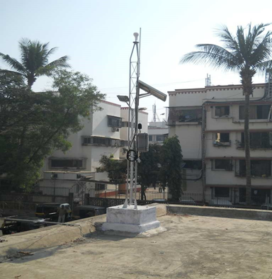

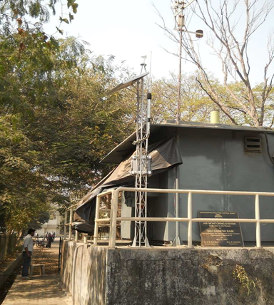

. As per the proposed road map 10 continuous monitoring stations are to be established in each of seven identified cities i.e. Mumbai, Delhi, Kolkata, Bangalore, Chennai, Lucknow and Hydra bad. Out of 10 stations proposed in Mumbai, 5 continuous monitoring stations have been installed at Mumbai/Navi Mumbai/Thane area at following locations:

**CONCLUSION:**

***Noise pollution can primarily start affecting the hearing ability of the person, causing permanent hearing impairment. Furthermore, it can cause an increase in blood pressure, hypertension, and other stress-related health issues.***

***Noise pollution can cause health problems for people and wildlife, both on land and in the sea. From traffic noise to rock concerts, loud or inescapable sounds can cause hearing loss, stress, and high blood pressure.***